**PROBLEM STATEMENT**

"Assessing and evaluating sales business performance is vital for a company to ensure alignment with its overall objectives and goals. This key assessment and evaluation are necessary to help identify its most highly performing, productive areas and equally highlight ailing methods or underperforming areas. Improvements and optimization strategies are drafted for underperforming areas, while modalities are also put in place to strengthen and sustain healthy aspects of the business. Hence, the objective of this analysis. The central goal of this project is analyzing the given company’s dataset to reveal patterns and trends that concisely highlight the company’s market strengths, opportunities, weaknesses, and underperforming areas. The insights gathered from this analysis will provide the company with the information necessary for making strategic business decisions to optimize performance and sustain success.

**DATA IMPORTATION AND CLEANING STEPS**

I first had to create a Database to host all the tables in order to carry out any exploration and analysis on the dataset. A descriptive name TDI_Capstone_Project that instantly suggest what the Database is about. After importing the tables I also performed checks for duplicates, but none of the four tables has duplicate rows. The columns titles in the four tables where in small cases. I used Stored Procedures to properly format the four table column titles.

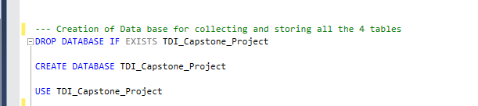

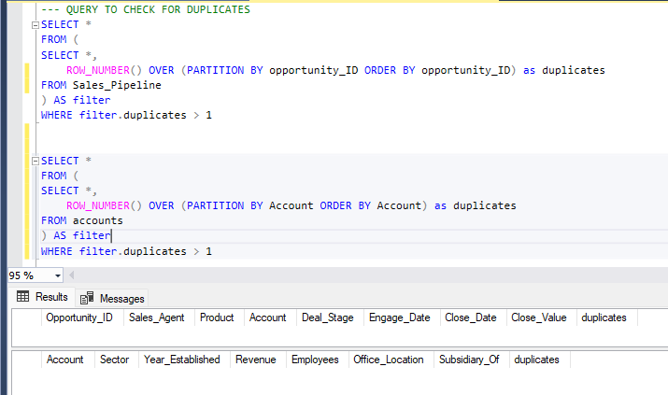

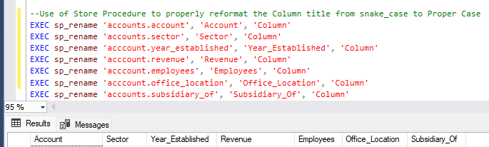

**OVERVIEW OF THE DATASETS.**

Four tables; Sales_Pipeline, Account, Sales_Team, and Products are utilized for the performance of this analysis

1. Sales_Pipeline table is the fact tables or transactional table that records all the sales event. It has the following columns
2. Opportunity_id: An identifier that uniquely identifies each sales event.
3. Sales_Agent: Records each sales representative that attempted or performed sales
4. Products: Identifies each product in that was sold.
5. Account: The name of the Company whose product whose product sold
6. Deal_Stage: Represent each stage or phase of the sales process Engage, Prospecting, Won and Lost
7. Engage_Date: The start or commencement date of the sales between the Sales Agent and Client
8. Close_Date: The date that the sales deal was won or closed.
9. Close Value: The revenue from the sales deal.
10. Products: Contains records for distinct products
11. Product_name: Name for each product
12. Series: A category for the products.
13. Sales_Price: Unit price for each product
14. Sales_Team:
15. Sales_agent: Column for each sale representative
16. Manager: Respective sales agents Manager.
17. Regional_Office: Region overseeing a collection of the company sales operational base
18. Accounts:
19. Account: Name of the company that manufactures each product
20. Sector: Specific industry that the company and products apply.
21. Year_Established: The establishment date of the company.
22. Revenue: Total sales value
23. Employees: Total number of employed staff.
24. Office_Location: The country where company is located and sales is taking place
25. Subsidiary_Of: Parent company product of company

**ENTITY RELATIONSHIPS**

Sales_Pipeline table serves as the Primary entity. It is referenced by the Sales_Team table, Account table, and product table.

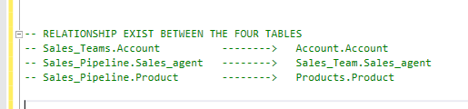

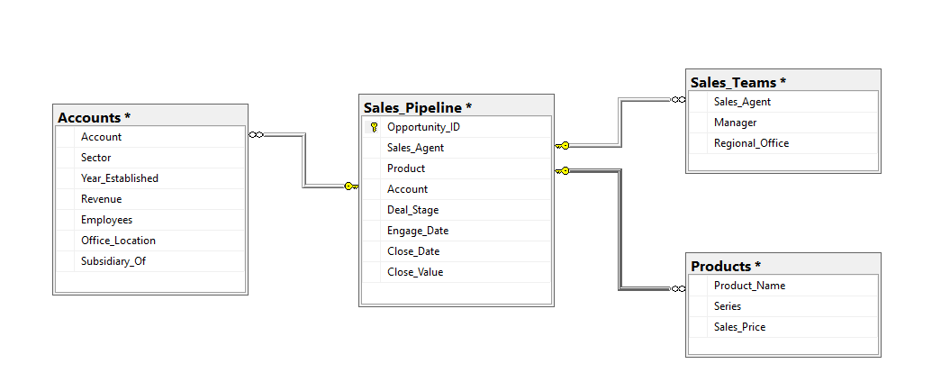

DEAL_STAGE Sales Analysis

The company recorded a total of 8,800 Sales Transactions. 4,238 (48.16%) of the sales transaction were WON. A total of 2473(28.1%) of sales fell through (lost). 1,589(18.06) of sales transaction are still ongoing(engaging) while 500 (5.58%) are on Prospect.

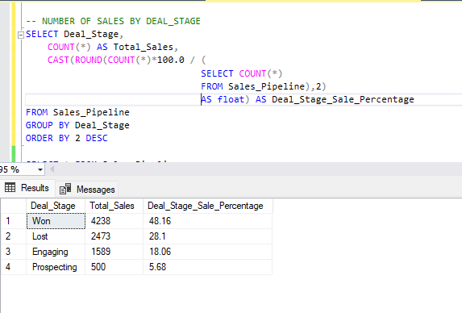

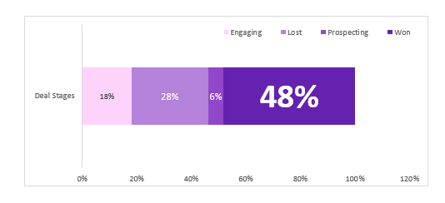

A total of $10,005,534 came into the company’s purse. All of the Companies revenue were generated from transaction deals that were WON or successfully concluded. The other deal stages generated no single revenue.

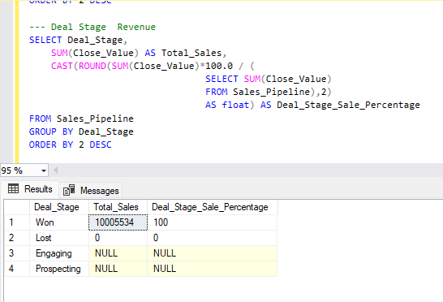

**MONTHLY CLOSE VALUE DISTRIBUTION**

The company monthly revenue posting has a tri-monthly predictable pattern with sales rising in the first month of each quarter and peaking in the last month. June contributed the highest in revenue generation – $ 1,338,466(13.38%). September comes in second Place with total close value posting of $1,235,264(12.35%). March posted $1,134,672(11.34%) in total Close Value. December and August recorded $ 1,131,573(11.31%) and $1,050,059(10.49%) respectively.

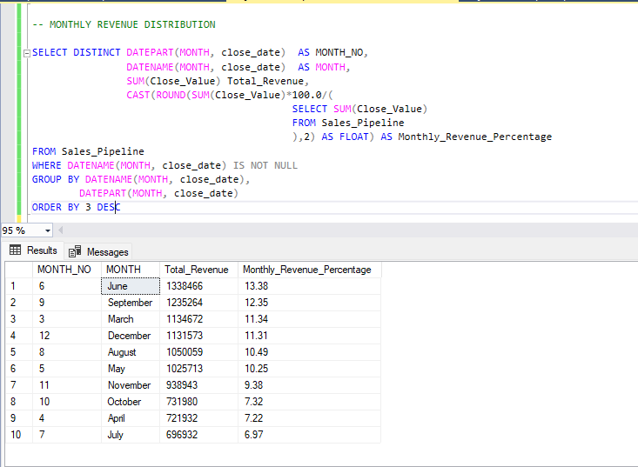

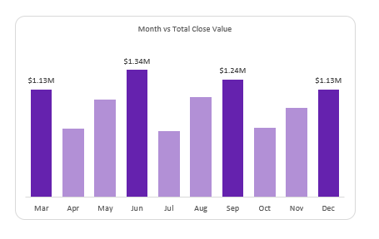

A MONTH OVER MONTH ANALYSIS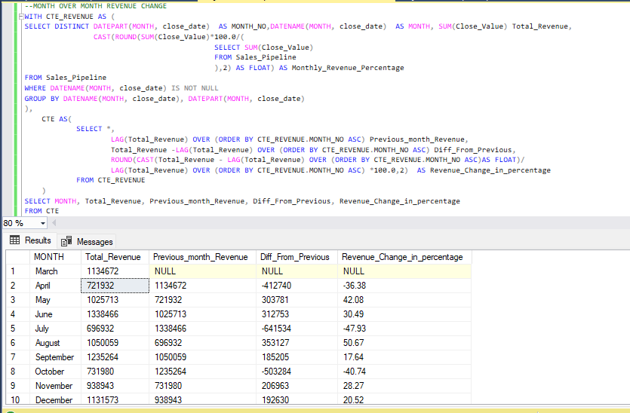

MONTHLY SALES DISTRIBUTION – DEALS WON

Month March and June Share the same figures in number of deals successfully close, both recording 531(6.03%). December, September, August round up the top five month in transactions successfully completed, both posting 511(5.81%), 503 (5.72%,) and 446(5.07%) respectively.

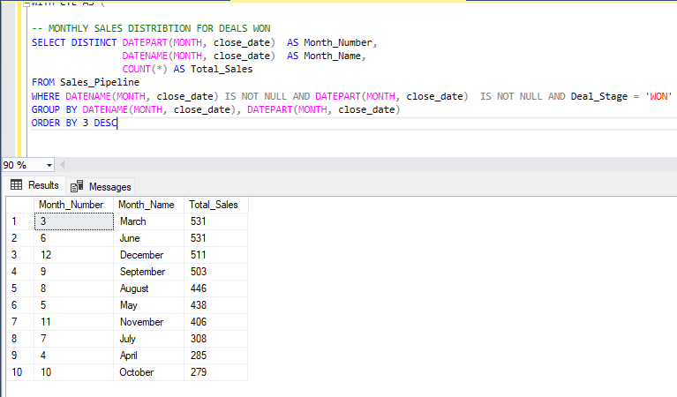

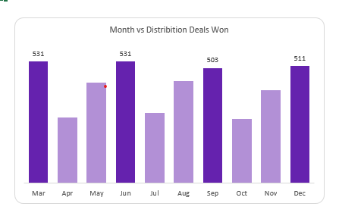

However, a month-over-month analysis shows that the performed better in May, June, August, September, November, and December compared to the preceding months.

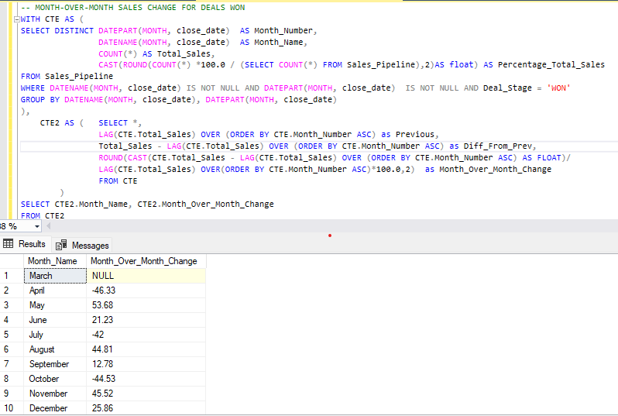

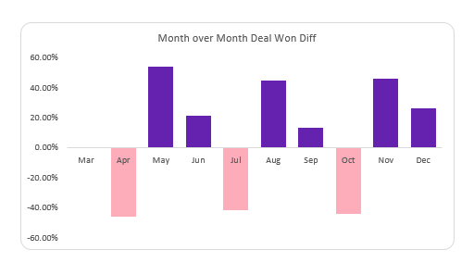

**RECOMMENDATION**

Since the dataset contains only a single operational year and lacks previous years for comparison, making data-driven, actionable recommendations is based on this single instance. However, moving forward, the following recommendations may prove useful.

Strategic Focus on High-Performing Months: Allocate additional resources and marketing efforts in the first and last months of each quarter, particularly focusing on June and September which have shown the highest revenue contributions. Implement targeted promotions and sales campaigns during these peak months to capitalize on the established pattern.

Conduct a proper evaluation to uncover factors leading to dips in sales during mid-quarter months (April, July, October) and implement strategies to maintain momentum throughout the quarter. Equally consider mid-quarter promotions or product launches to boost sales during these typically slower periods. Analyze the specific needs and preferences of customers during peak months to tailor marketing messages and product offerings accordingly.

**REGION AND COUNTRY/OFFICE LOACTIONS ANALYSIS**

The Central region was the top most transactional region recording 1,629(18.51%) won deals. The West trails the central region in second place, contributing 1438(16.34%) in Won Deals. East sits last, earning the company 1,171(13.31) in deals won.

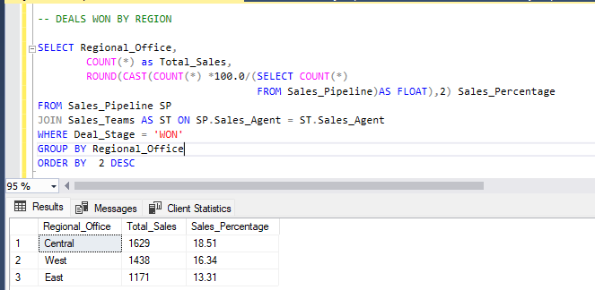

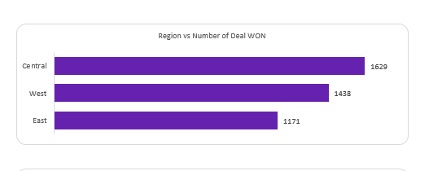

In Close Value, The West region eclipses Central region, contributing $3,568,647(35.67%) in Close Value, the latter contributing $3,346,293 (33.44%). East occupies the last spot, bringing in $3,090,594(30.89%) in close value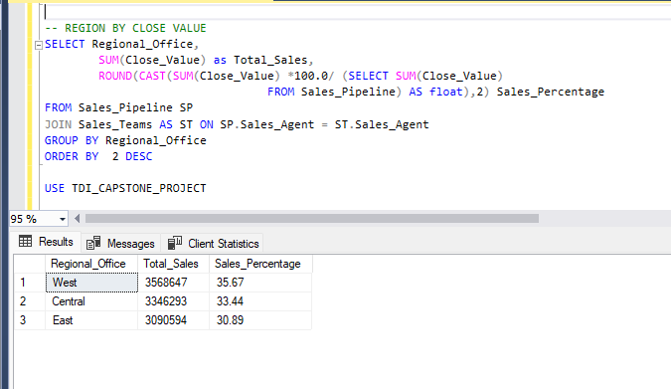

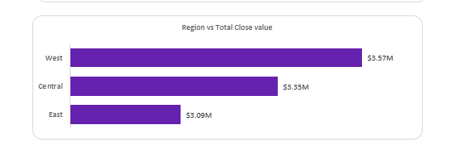

**RECOMMENDATION**

Central and west regions have clearly shown prominent contributions in both categories – Deals WON and Close value. This shows the two regions are receptive and lucrative business grounds to the company. The company should look to strengthening their already existing strong dominance in both marketing through targeted and tailored marketing; identify the regions strong demands and develop products and strategies that effectively caters to the demands from both regions. While the East regions lags behind the two regions, it still contributes handsomely to the company’s bottom line. Conducting research to identify the regions critical needs and catering to them should markedly raise and improve the regions numbers for the company.

**OFFICE LOCATION/COUNTRY ANALYSIS**

The United States contributes a substantial 84.22% of the company's total close deals, clearly representing the company's largest market. Despite this dominance, the average sales price in the USA is lower compared to other countries, where the USA ranks fourth in terms of high unit price product purchases. Given the limited variables of the dataset, it is challenging to definitively identify the reasons behind the lower number of deals and close values in other countries. Possible reasons could include the location of major customers, regional customer preferences, higher demand and usage of products in the USA, or the company's strategic focus on the US market.

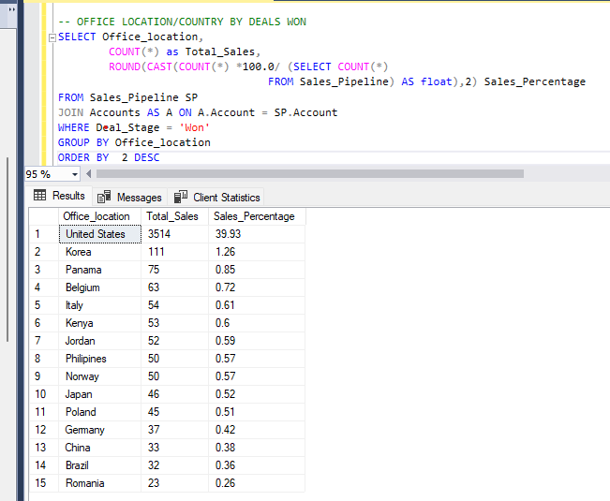

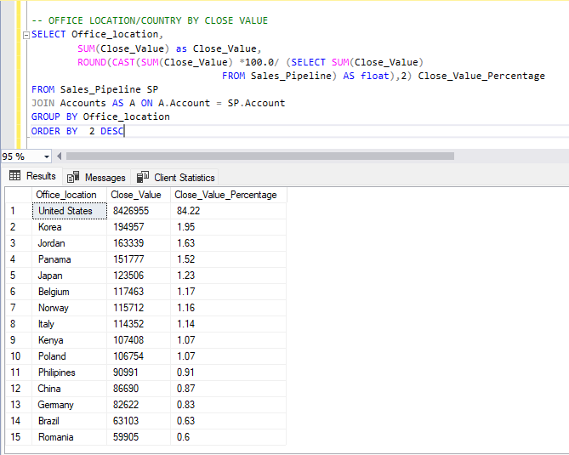

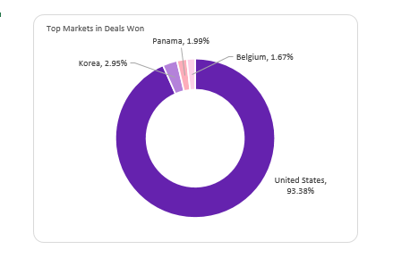

**RECOMMENDATIONS**

Conduct a detailed analysis to understand the market dynamics in other countries. Investigate factors such as customer preferences, local demand, competitive landscape, and regulatory environments that might influence sales performance. Also consider assessing and adjusting the sales strategies in international markets. This might involve training for local sales teams, refining sales pitches, or adjusting pricing strategies to be more competitive and explore the possibility of partnerships with local businesses or distributors to expand reach and improve market penetration.

**SECTOR ANALYSIS**

Four Sectors Retail, Medical, technology and Software have proven to be the sectors with the highest engagements rate. Retail eads with a close value of $1,867,528, contributing 18.66% of the total close value. Technology follows closely with $1,515,487, accounting for 15.15%. Medical holds the third position with $1,359,595, representing 13.59%. The top three sectors (Retail, Technology, and Medical). combined contribute 47.4% of the total close value, highlighting their critical importance to the company's revenue. Software and Finance sectors contribute significantly with close values of $1,077,934 (10.77%) and $950,908 (9.5%) respectively. Marketing also shows a strong performance with $922,321, making up 9.22% of the total. Entertainment ($689,007; 6.89%), Telecommunications ($653,574; 6.53%), Services ($533,006; 5.33%), and Employment ($436,174; 4.36%) contribute less to the total close value but still represent viable market segments.

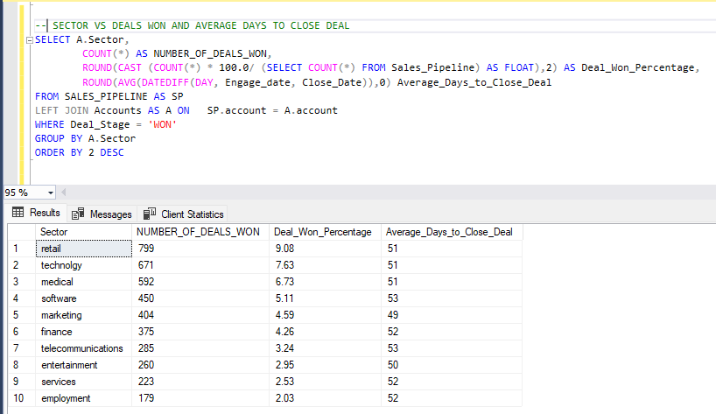

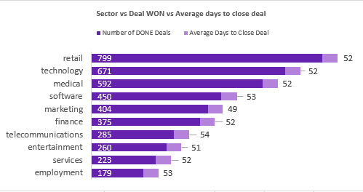

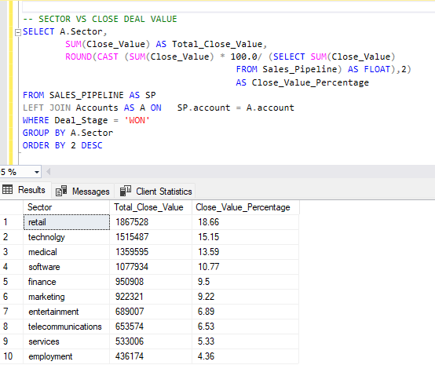

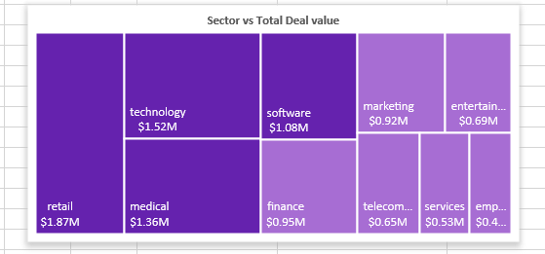

A correlation shows a moderate relationship between the revenue and employee size of the sectors and how much the company closes in deals. This positive relationship suggest that the company should develop products and marketing strategies that are tailored to needs of heavily staffed sectors while also offering options suitable to moderately staffed industries.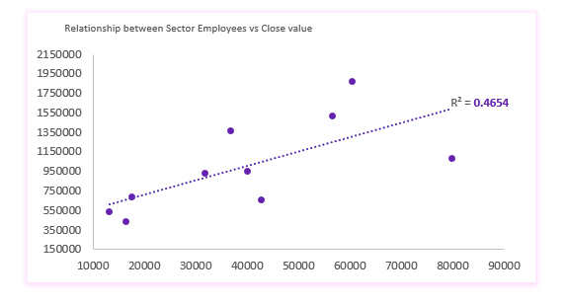

**RECOMMENDATIONS:**

Focus on High-Performing Sectors: Retail, Technology, and medical sectors should be prioritized for product development and marketing efforts due to their substantial contribution to revenue. Tailoring products and services to meet the specific needs of these industries can certainly drive further growth.

Strengthen Mid-Level Sector Strategies: Enhance marketing campaigns and develop targeted solutions for the Software, Finance, and Marketing sectors to capitalize on their significant revenue contributions. Consider personalized engagement strategies to boost sales in these areas.

Expand Efforts in Lower Performing Sectors: While sectors like Entertainment, Telecommunications, Services, and Employment contribute less to the overall revenue, they still hold potential. Analyze the unique needs of these industries and create niche marketing strategies to increase their close values.

Balanced Product Portfolio: as the correlation suggest, the company should ensure a balanced product portfolio that caters not only to the heavily staffed sectors but also provides relevant options for moderately staffed industries. This diversification can help mitigate risks and tap into a broader market base.

**SALES AGENT PERFORMANCE**

Darcel Schlecht stands out as the top Sales Agent, leading in both the total number of deals won - 349 and the highest revenue generated - $1,153,214. His impressive closing value margin is more than double that of the second-highest performer, Vicki Laflamme ($478,396). His performance nearly matches the combined total close values of the next three top agents (Vicki Laflamme, Kary Hendrixson, and Cassey Cress) which is $1,383,183. Vicki Laflamme, Kary Hendrixson, and Cassey Cress are notable performers with substantial total close values ($478,396, $454,298, and $450,489 respectively). They represent valuable assets to the sales team with high productivity levels. However, a number of sales agents **James Ascencio, Elease Gluck, and Rosalina Dieter,** have also contributed moderately to the company. Their moderate performance might likely be due to the difficulty or technicality that comes with marketing high-value products.

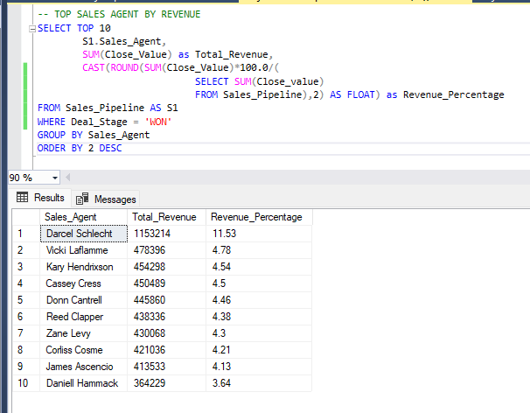

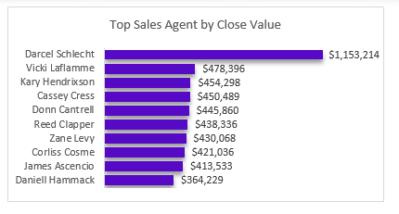

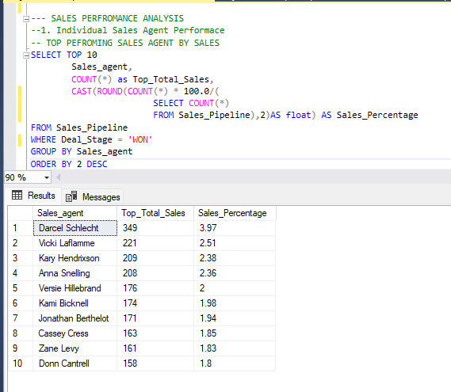

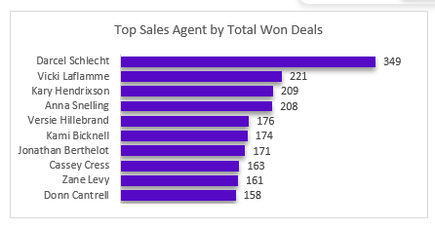

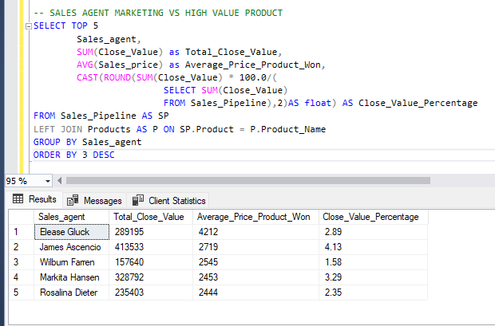

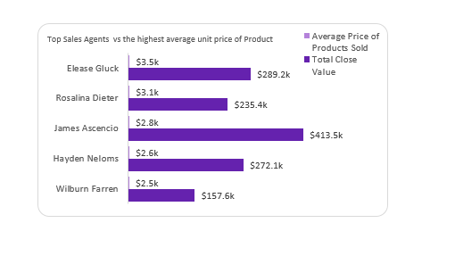

**RECOMMENDATION**

1. Implement a rewards and recognition program to boost the morale and retain top performers like Darcel Schlecht and Vicki Laflamme. Offer bonuses, increased commissions, or career advancement opportunities to further motivate these high achievers.
2. **Training and Development:** Analyze Darcel Schlecht’s sales techniques and strategies to identify best practices that he utilizes that can be shared with the rest of the sales team. Conduct workshops or training sessions to improve the overall performance of other sales agents such as Elease Gluck, Rosalina Dieter, James Ascencio, Hayden Neloms who market high-priced products but generate low close value.
3. **Focus on promising markets, clients or High-Value Deals:** Encourage sales agents to focus on markets, high-value deals or products that aligns with and responds to their capabilities similar to Darcel Schlecht’s approach. This might involve targeting larger clients or higher-priced products to maximize revenue.

**PRODUCTS ANALYSIS**

Products: GTX Basic, MG Special, and GTX Pro have the highest successful sales rates, while GTX Pro, GTX Plus Pro, and MG Advanced contributed the most in Close value. However, the product with the most significant market value is the GTK 500. Despite having just 15 sales, it boasts a commendable close value margin and holds the potential to generate even more value if it achieves one-quarter other products won deal rate.

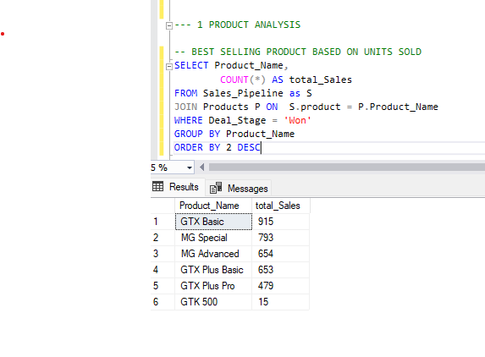

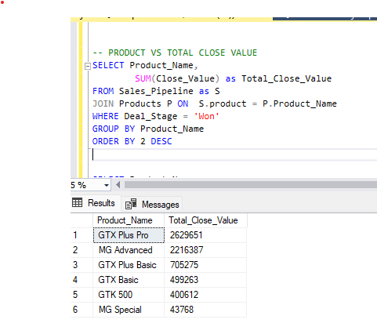

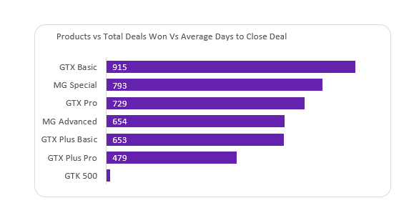

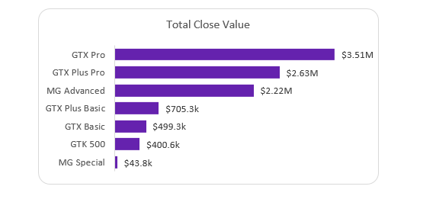

.

**RECOMMENDATIONS**

1. Given the substantial revenue generated by GTX Pro, GTX Plus Pro, and MG Advanced, allocate more resources to marketing and sales efforts for these products and since high-value deals can take longer time to close, streamline and optimize the sales process for these deals. This might include better qualification of leads, enhanced sales training, or improved customer relationship management.
2. Conduct thorough research both on current markets, regions and companies were GTK 500 is selling and potential markets, regions and companies that could be in need of GTK 500 and develop compelling market strategy – such as revised price strategy, quality rebranding, target marketing, offering discounts, promos, bundles sales, etc. to attract more customers and boost sales. Train Elease Gluck, Markita Hansen, Rosalina Dieter who are the three Sales Agents that have successfully conclude sales for GTK 500 and incorporate the marketing genius of the likes of Darcel Schlecht, Vicki Laflamme, Kary Hendrixson, and Cassey Cress to join in marketing and pushing sales for GTK 500.

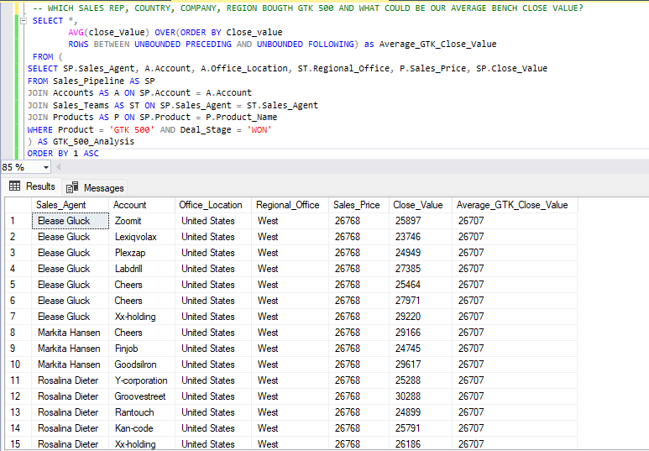

**CONCLUSION**

Evaluating and assessing SalesBlitz's business performance and market prospects is vital for ensuring that the company operates in alignment with its overall objectives and goals. This analysis has been meticulously segmented to address various aspects of SalesBlitz, enabling a comprehensive understanding of the company's health. By identifying both high-performing and underperforming areas, the findings provide stakeholders with actionable insights. These insights should be crucial for taking proactive measures and developing optimal strategies to enhance operations and fortify the strengths of the business.